**RISK MANAGEMENT**

**HOMEWORK**

TO STUDENTS OF SUSTAINABLE CORPORATE FINANCE & INVESTMENT MASTER PROGRAMME

Homework is an integral part of the final assessment. Taking into account the scope and design of correctly solved tasks, the teacher evaluates the homework. This assessment constitutes 20% of the final grade.

Homework is submitted to the teacher before or during the exam in print or electronic form. [arvydas@paskevicius.com](mailto:arvydas@paskevicius.com)

The student must solve the tasks below, print the cover page (the example is given at the end of the task) and staple it.

**3. The Balance of Payments**

**3.1 Classifying Transactions**. Classify each of the following as a transaction reported in a sub-component of the current account or of the capital and financial accounts of the two countries involved:

a.A U.S. food chain imports wine from Chile.

b.A U.S. resident purchases a euro-denominated bond from a German company.

c.Singaporean parents pay for their daughter to study at a U.S. university.

d.A U.S. university gives a tuition grant to a foreign student from Singapore.

e.A British company imports Spanish oranges, paying with eurodollars on deposit in London.

f.The Spanish orchard deposits half its proceeds into a eurodollar account in London.

g.A London-based insurance company buys U.S. corporate bonds for its investment portfolio.

h.An American multinational enterprise buys insurance from a London insurance broker.

i.A London insurance firm pays for losses incurred in the United States because of an international terrorist attack.

j.Cathay Pacific Airlines buys jet fuel at Los Angeles International Airport so it can fly the return segment of a flight back to Hong Kong.

k.A California-based mutual fund buys shares of stock on the Tokyo and London stock exchanges.

l.The U.S. army buys food for its troops in South Asia from local vendors.

m.A Yale graduate gets a job with the International Committee of the Red Cross in Bosnia and is paid in Swiss francs.

n.The Russian government hires a Norwegian salvage firm to raise a sunken submarine.

o.A Colombian drug cartel smuggles cocaine into the United States, receives a suitcase of cash, and flies back to Colombia with that cash.

p.The U.S. government pays the salary of a Foreign Service officer working in the U.S. embassy in Beirut.

q.A Norwegian shipping firm pays U.S. dollars to the Egyptian government for passage of a ship through the Suez Canal.

r.A German automobile firm pays the salary of its executive working for a subsidiary in Detroit.

s.An American tourist pays for a hotel in Paris with his American Express card.

t.A French tourist from the provinces pays for a hotel in Paris with his American Express card.

u.A U.S. professor goes abroad for a year on a Fulbright grant.

**4. The Foreign Exchange Market**

**4.1.** **Asian Pacific Crisis (1997).** The Asian financial crisis which began in July 1997 wreaked havoc throughout the currency markets of East Asia.

|  |  |  |  |
| --- | --- | --- | --- |
|  |  | **July 1997** | **November 1997** |
| **Country** | **Currency** | **(per US$)** | **(per US$** |
| **China** | **yuan** | **8,40** | **8,40** |
| **Hong Kong** | **dollar** | **7,75** | **7,73** |
| **Indonesia** | **rupiah** | **2 400** | **3 600** |
| **Korea** | **won** | **900** | **1 100** |
| **Malaysia** | **ringgit** | **2,50** | **3,50** |
| **Philippines** | **peso** | **27** | **34** |
| **Singapore** | **dollar** | **1,43** | **1,60** |
| **Taiwan** | **dollar** | **27,80** | **32,70** |
| **Thailand** | **baht** | **25,0** | **40,0** |

a. Which of the following currencies had the largest depreciations or devaluations during the July to November period?

b. Which seemingly survived the first five months of the crisis with the least impact on their currencies?

**4.2. Japanese Yen Forward**. Use the following spot and forward bid-ask rates for the Japanese yen/U.S. dollar (¥/$) exchange rate from September 16, 2010, to answer the following questions:

|  |  |  |
| --- | --- | --- |
| **Period** | **¥/$ Bid Rate** | **¥/$ Ask Rate** |
| spot | 85,41 | 85,46 |
| 1 month | 85,02 | 85,05 |
| 2 months | 84,86 | 84,90 |
| 3 months | 84,37 | 84,42 |
| 6 months | 83,17 | 83,20 |
| 12 months | 82,87 | 82,91 |
| 24 months | 81,79 | 81,82 |

a. What is the mid-rate for each maturity?

b. What is the annual forward premium for all maturities? (use mid-rates)

c. Which maturities have the smallest and largest forward premiums?

**4.3. Andreas Broszio (Geneva**). Andreas Broszio just started his job as an analyst for Credit Suisse in Geneva, Switzerland. He receives the following quotes for Swiss francs against the dollar for spot, 1 month forward, 3 months forward, and 6 months forward.

|  |  |
| --- | --- |
| Spot exchange rate: |  |
| Bid rate | SF 1.2575/$ |
| Ask rate | SF 1.2585/S |
| One-month forward | 10 to 15 |
| 3-months forward | 14 to 22 |
| 6-months forward | 20 to 30 |

a. Calculate outright quotes for bid and ask and the number of points spread between each.

b. What do you notice about the spread as quotes evolve from spot toward 6 months?

**4.4. Study Abroad**: Paris to Moscow. On your summer study abroad program in Europe, you stay an extra two weeks to travel from Paris to Moscow. You leave Paris with 2,000 euros (€ or EUR) in your belt pack. Wanting to exchange all of these for Russian rubles (₽ or RUB), you obtain the following quotes:

Spot rate (USD = 1.00 EUR or $/€) 1.1280

Spot rate (RUB = 1.00 USD or R/$) 62.40

a) What is the Russian ruble/euro cross rate?

b) How many rubles will you obtain for your euros?

**4.5. Bid/Ask on Swiss franc/Euro Forwards**. Use the following spot and forward bid-ask rates for the Swiss franc/euro (CHF/€) from October 28, 2019, to answer the following questions:

a.What is the mid-rate for each maturity?

b.What is the annual forward premium for all maturities?

c.Which maturities have the smallest and largest forward premiums?

|  |  |  |
| --- | --- | --- |
|  | **CHF/€** | **CHF/€** |
| **Period** | **Bid Rate** | **Ask Rate** |
| **spot** | 1,1027 | 1,1033 |
| **1 month** | 1,1030 | 1,1035 |
| **2 months** | 1,1033 | 1,1071 |
| **3 months** | 1,1038 | 1,1042 |
| **6 months** | 1,1049 | 1,1050 |
| **12 months** | 1,1068 | 1,1068 |
| **24 months** | 1,1109 | 1,1093 |

**4.6. Vienna Corporate Treasury**. A corporate treasury working out of Vienna with operations in New York simultaneously calls Citibank in New York City and Barclays in London. The banks give the following quotes on the euro simultaneously:

|  |
| --- |
| **Citibank NYC Barclays London** |
| $0.7551-61/€ $0.7545-75/€ |

Using $1 million or its euro equivalent, show how the corporate treasury could make geographic arbitrage profit with the two different exchange rate quotes

**4.7. Around the Horn**. Assuming the following quotes, calculate how a market trader at Citibank with $1,000,000 can make an intermarket arbitrage profit.

Citibank quotes U.S. dollar per pound $1.5900 = £1.00

National Westminster quotes euros per pound €1.2000 = £1.00

Deutschebank quotes U.S. ­dollar per euro $0.7550 = €1.00

**4.8. Great Pyramids**. Inspired by his recent trip to the Great Pyramids, Citibank trader Ruminder Dhillon wonders if he can make an intermarket arbitrage profit using Libyan dinars (LYD) and Saudi riyals (SAR). He has USD1,000,000 to work with so he gathers the following quotes. Is there an opportunity for an arbitrage profit?

Citibank quotes U.S. dollar per Libyan dinar $1.9324 = LYD1.00

National Bank of Kuwait quotes Saudi riyal per Libyan dinar SAR1.9405 = LYD1.00

Barclay quotes U.S. dollar per Saudi riyal $0.2667 = SAR1.00

**5. International Parity Conditions**

**5.1. Hyundai’s Pass-Through**. Assume that the export price of a Hyundai Sonata from Seoul, South Korea, is ₩23,460,000. It exports the car to Malaysia. The exchange rate is ₩279.48/RM. The forecast inflation rate in Malaysia is 2.0% per year and in South Korea it is 1.5% per year. Use these data to answer the following questions on exchange rate pass-through.

a.What was the export price for the Sonata at the beginning of the year expressed in Malaysian ringgit?

b.Assuming purchasing power parity holds, what should be the exchange rate at the end of the year?

c.Assuming 100% exchange rate pass-through, what will be the Malaysian ringgit price of a Sonata at the end of the year?

d.Assuming 60% exchange rate pass-through, what will be the Malaysian ringgit price of a Sonata at the end of the year?

**5.2. Kamada: CIA Japan (A).** Takeshi Kamada, a foreign exchange trader at Credit Suisse (Tokyo), is exploring covered interest arbitrage possibilities.

He wants to invest $5,000,000 or its yen equivalent in a covered interest arbitrage between U.S. dollars and Japanese yen. He faced the following exchange rate and interest rate quotes. Is CIA profit possible? If so, how?

Arbitrage funds available $5,000,000

Spot rate (¥/$) 118.60

180-day forward rate (¥/$) 117.80

180-day U.S. dollar interest rate 4.800%

180-day Japanese yen interest rate 3.400%

**5.3. Copenhagen Covered (A)**. Heidi Høi Jensen, a foreign exchange trader at JPMorgan Chase, can invest $5 million, or the foreign currency equivalent of the bank’s short-term funds, in a covered interest arbitrage with Denmark. Using the following quotes, can Heidi make a covered interest arbitrage (CIA) profit?

Arbitrage funds available $5,000,000

Spot exchange rate (kr/$) 6.1720

3-month forward rate (kr/$) 6.1980

U.S. dollar 3-month interest rate 3.000%

Danish kroner 3-month interest rate 5.000%

**5.4. Copenhagen Covered (B).** Heidi Høi Jensen is now evaluating the arbitrage profit potential in the same market after interest rates change. (Note that any time the difference in interest rates does not exactly equal the forward premium, it must be possible to make a CIA profit one way or another.)

Arbitrage funds available $5,000,000

Spot exchange rate (kr/$) 6.1720

3-month forward rate (kr/$) 6.1980

U.S. dollar 3-month interest rate 4.000%

Danish kroner 3-month interest rate 5.000%

**5.5 Trans-Atlantic Quotes**. Separated by more than 3,000 nautical miles and five time zones, money and foreign exchange markets in both London and New York are very efficient. The following information has been collected from the respective areas:

Assumptions London New York

Spot exchange rate ($/€) 1.3264 1.3264

1-year Treasury bill rate 3.900% 4.500%

Expected inflation rate Unknown 1.250%

a.What do the financial markets suggest for inflation in Europe next year?

b.Estimate today’s 1-year forward exchange rate between the dollar and the euro..

**5.6. Chamonix Rentals.** You are planning a ski vacation to Mt. Blanc in Chamonix, France, one year from now. You are negotiating the rental of a chateau. The chateau’s owner wishes to preserve his real income against both inflation and exchange rate changes, and so the present weekly rent of €9,800 (Christmas season) will be adjusted upward or downward for any change in the French cost of living between now and then. You are basing your budgeting on purchasing power parity (PPP). French inflation is expected to average 3.5% for the coming year, while U.S. dollar inflation is expected to be 2.5%. The current spot rate is $1.3620/€. What should you budget as the U.S. dollar cost of the 1-week rental?

Spot exchange rate ($/€) $1.3620

Expected U.S. inflation for coming year 2.500%

Expected French inflation for coming year 3.500%

Current chateau nominal weekly rent (€) 9,800.00

**6. Foreign Exchange Rate Determination and Intervention**

**6.1. Ecuadorian Sucre.** The Ecuadorian sucre (S) suffered from hyper-inflationary forces throughout 1999. Its value moved from S5,000/$ to S25,000/$. What was the percentage change in its value?

**6.2. Canadian Dollar/USD Dollar**. The Canadian dollar’s value against the U.S. dollar has seen some significant changes over recent history. Use the following graph of the C$/US$ exchange rate for the 30-year period between 1980 and end-of-year 2010 to estimate the percentage change in the Canadian dollar’s value (affectionately known as the “loonie”) versus the dollar for the following periods.

a.January 1980–January 1986

b.January 1986–October 1991

c.October 1991–December 2001

d.October 2001–April 2011

e.April 2011–January 2015

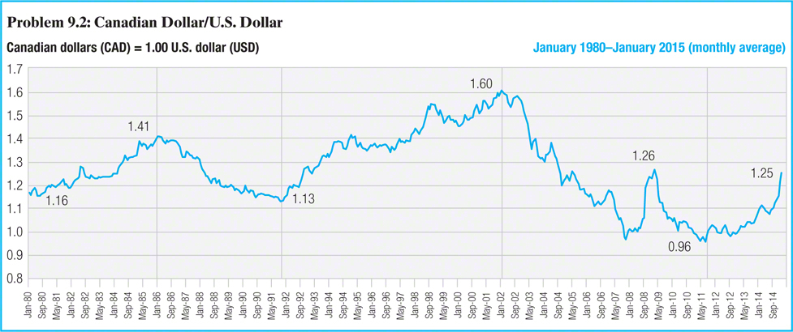

**6.3. Current Spot Rates**. What are the current spot exchange rates for the following cross-rates?

a.Japanese yen/U.S. dollar exchange rate

b.Japanese yen/Australian dollar exchange rate

c.Australian dollar/U.S. dollar exchange rate



**6.4. Purchasing Power Parity Forecasts**. Assuming purchasing power parity, and that the forecasted change in consumer prices is a good proxy of predicted inflation, forecast the following cross-rates:

a.Japanese yen/U.S. dollar in one year

b.Japanese yen/Australian dollar in one year

c.Australian dollar/U.S. dollar in one year

**6.5. International Fisher Forecasts**. Assuming International Fisher—one version of Purchasing Power Parity—applies to the coming year, forecast the following future spot exchange rates using the government bond rates for the respective country currencies:

a.Japanese yen/U.S. dollar in one year

b.Japanese yen/Australian dollar in one year

c.Australian dollar/U.S. dollar in one year

**6.6. Implied Real Interest Rates**. If the nominal interest rate is the government bond rate, and the current change in consumer prices is used as expected inflation, calculate the implied “real” rates of interest by currency.

a.Australian dollar “real” rate

b.Japanese yen “real” rate

c.U.S. dollar “real” rate

**6.7. Forward Rates**. Using the spot rates and 3-month interest rates in the table, calculate the 90-day forward rates for:

a.Japanese yen/U.S. dollar exchange rate

b.Japanese yen/Australian dollar exchange rate

c.Australian dollar/U.S. dollar exchange rate

**7. Foreign Currency Derivatives: Futures and Options**

**7.1. Mariko Fujimoto at Sakura Bank**. Mariko Fujimoto, a currency trader for Tokyo-based Sakura Bank, uses the following futures quotes on the British pound (£) to speculate on the value of the pound.

a.If Mariko buys 5 March pound futures, and the spot rate at maturity is ¥139.95/£, what is the value of her position?

b.If Mariko sells 12 December pound futures, and the spot rate at maturity is ¥138.90/£, what is the value of her position?

c.If Mariko buys 3 December pound futures, and the spot rate at maturity is ¥138.90/£, what is the value of her position?

d.If Mariko sells 12 March pound futures, and the spot rate at maturity is ¥139.95/£, what is the value of her position?

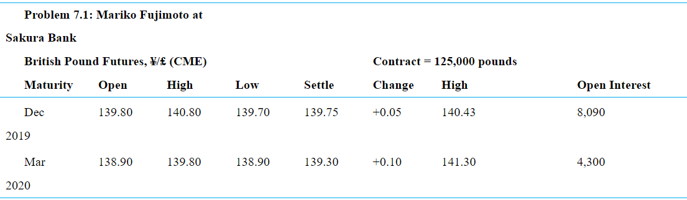

**7.2. Cece Cao in Jakarta**. Cece Cao trades currencies for Sumatra Funds in Jakarta. She focuses nearly all of her time and attention on the U.S. dollar/Singapore dollar ($/S$) cross-rate. The current spot rate is $0.6000/S$. After considerable study, she has concluded that the Singapore dollar will appreciate versus the U.S. dollar in the coming 90 days, probably to about $0.7000/S$. She has the following options on the Singapore dollar to choose from:

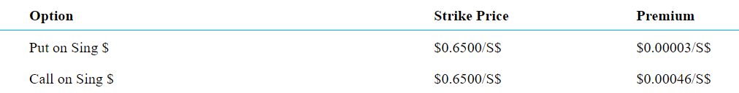

a.Should Cece buy a put on Singapore dollars or a call on Singapore dollars?

b.What is Cece’s break-even price on the option purchased in part (a)?

c.Using your answer from part (a), what is Cece’s gross profit and net profit (including premium) if the spot rate at the end of 90 days is indeed $0.7000/S$?

d.Using your answer from part (a), what is Cece’s gross profit and net profit (including premium) if the spot rate at the end of 90 days is $0.8000/S$?

**7.3. Hoffman Bank, Basel (A).** Stefan Boerig trades currency for the Hoffman Bank in Basel, Switzerland. Stefan has 10 million Swiss francs (SF) to begin with, and he must state all profits at the end of any speculation while the 30-day forward rate is SF1.1027/€.

a.If Stefan believes the euro will continue to rise in value against the Swiss franc and expects the spot rate to be SF1.1375/€ at the end of 30 days, what should he do?

b.If Stefan believes the euro will depreciate in value against the Swiss franc and expect the spot rate to be SF1.0925/€ at the end of 30 days, what should he do?

**7.4. Hoffman Bank, Basel (B).** Stefan Boerig of Hoffman Bank now believes that the Swiss franc will appreciate against the British pound in the coming 3-month period. He has £250,000 to invest. The current spot rate is £0.7829/SF, the 3-month forward rate is £0.7640/SF, and he expects the spot rates to reach £0.7995/SF in three months.

a.Calculate Stefan’s expected profit, assuming a pure spot market speculation strategy.

b.Calculate Stefan’s expected profit, assuming he buys or sells Swiss francs three months forward.

**7.5.** **Kiko Peleh’s Puts**. Kiko Peleh writes a put option on Japanese yen with a strike price of $0.008000/¥ (¥125.00/$) at a premium of 0.0080¢ per yen and with an expiration date six months from now. The option is for ¥12,500,000. What is Kiko’s profit or loss at maturity if the ending spot rates are ¥110/$, ¥115/$, ¥120/$, ¥125/$, ¥130/$, ¥135/$, and ¥140/$?

**7.6. Valdor Capital**. Baradan Kuppusamy works as a currency speculator for Valdor Capital headquartered in Kuala Lumpur. His most recent speculative position is to profit from his expectation that the Thai baht will rise significantly against the Malaysian ringgit. The current spot rate is RM0.1382/฿. He must choose between the following 90-day options on the Malaysian ringgit.

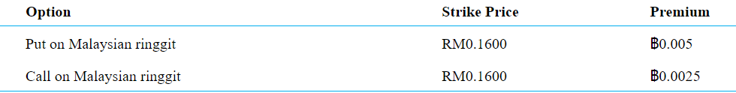

a.Should Baradan buy a put on Malaysian ringgit or a call on Malaysian ringgit?

b.What is Baradan’s break-even price on the option purchased in part (a)?

c.Using your answer from part (a), what are Baradan’s gross profit and net profit (including premium) if the spot rate at the end of 90 days is RM0.2000/฿?

**7.7. Henrik’s Options**. Assume Henrik writes a call option on euros with a strike price of $1.2500/€ at a premium of 3.80 cents per euro ($0.0380/€) and with an expiration date three months from now. The option is for 100,000 euros. Calculate Henrik’s profit or loss should he exercise before maturity at a time when the euro is traded spot at strike prices beginning at $1.10/€, rising to $1.40/€ in increments of $0.05.

**8. Transaction Exposure**

**8.1. Bobcat Company**. Bobcat Company, a U.S.-based manufacturer of industrial equipment, just purchased a Korean company that produces ­plastic nuts and bolts for heavy equipment. The purchase price was ₩7,500 million. ₩1,000 million has already been paid, and the remaining ₩6,500 ­million is due in six months. The current spot rate is ₩1,110/$, and the 6-month forward rate is ₩1,175/$. The 6-month Korean won interest rate is 16% per annum, the 6-month U.S. dollar rate is 4% per annum. Bobcat can invest at these interest rates, or borrow at 2% per annum above those rates. A 6-month call option on won with a ₩1,200/$ strike rate has a 3.0% premium, while the 6-month put option at the same strike rate has a 2.4% premium. Bobcat can invest at the rates given previously, or borrow at 2% per annum above those rates. Bobcat’s weighted average cost of capital is 10%. Compare alternate ways that Bobcat might deal with its foreign exchange exposure. What do you recommend and why?

**8. 2. Elan Pharmaceuticals**. Elan Pharmaceuticals, a U.S.-based multinational pharmaceutical ­company, is evaluating an export sale of its cholesterol reduction drug with a prospective Indonesian distributor. The purchase would be for 1,650 million Indonesian rupiah (Rp), which at the current spot exchange rate of Rp9,450/$ translates into nearly $175,000. Although not a big sale by company standards, company policy dictates that sales must be settled for at least a minimum gross margin, in this case, a cash settlement of $168,000. The current 90-day forward rate is Rp9,950/$. Although this rate appeared unattractive, Elan had to contact several major banks before even finding a forward quote on the rupiah. The consensus of currency forecasters at the moment, however, is that the rupiah will hold relatively steady, possibly falling to Rp9,400/$ over the coming 90 to 120 days. Analyze the prospective sale and make a hedging recommendation.

VILNIUS UNIVERSITY

BUSINESS SCHOOL

SUSTAINABLE CORPORATE FINANCE & INVESTMENT MASTER PROGRAMME

RISK MANAGEMENT

Master's student Name Surname

Master's signature ___________

Head of work prof. Dr. Arvydas Paškevičius

Evaluation of the work _______________

Head of work signature ______________

Vilnius 2023-02-02